Sampling Rate Conversion: 16 kHz → 24 kHz
Analysis of Interpolation/Decimation Factor Error and MATLAB Implementation

1. Problem Statement
A sampling rate conversion system is designed to convert a 16 kHz signal to 24 kHz using an interpolation factor L and a decimation factor M. The original design specified L = 2 and M = 3, which produced an output sampling frequency of 10.67 kHz instead of the intended 24 kHz.

2. Root Cause Analysis
For a rational sample-rate converter, the output sampling frequency is related to the input by:
Fout = Fin × (L / M)
Substituting the original (incorrect) factors L = 2, M = 3:
Fout = 16000 × (2/3) = 10666.7 Hz ✗
This confirms the reported 10.67 kHz output was arithmetically consistent with L = 2, M = 3 — but that ratio is wrong for the stated goal. To raise the sampling rate from 16 kHz to 24 kHz, the ratio L/M must equal Fout/Fin = 24000/16000 = 3/2, which requires the interpolation factor to be larger than the decimation factor, not smaller.
- Error: The interpolation factor (L) and decimation factor (M) were swapped.
- L = 2, M = 3 actually implements the reverse conversion (24 kHz → 16 kHz), not 16 kHz → 24 kHz.
- Correct factors: L = 3 (interpolation), M = 2 (decimation), giving Fout = 16000 × 3/2 = 24000 Hz.

3. Corrected Calculation
Parameter | Value
Input sampling frequency (Fin) | 16000 Hz
Target output sampling frequency | 24000 Hz
Erroneous factors | L = 2, M = 3
Erroneous output (Fin × L/M) | 10666.7 Hz
Corrected factors | L = 3, M = 2
Corrected output (Fin × L/M) | 24000 Hz

4. Implementation Approach
The corrected system was implemented in MATLAB as an explicit two-stage cascade:
- Stage 1 — Interpolation by L = 3: insert (L−1) zeros between input samples, then apply an anti-imaging FIR lowpass filter (gain L to compensate for zero-insertion loss).
- Stage 2 — Decimation by M = 2: apply an anti-aliasing FIR lowpass filter at the intermediate rate (Fin × L = 48000 Hz), then discard every Mth sample.
- Cutoff frequency for both filters set to min(Fin, Fout)/2 = 8000 Hz to prevent both imaging and aliasing.
- Result cross-checked against MATLAB's built-in resample(x, L, M) function for verification.

5. MATLAB Code (Corrected)
%% Sampling Rate Conversion: 16 kHz -> 24 kHz
% CORRECTED VERSION
%
% ERROR IN ORIGINAL DESIGN:
% Original used L = 2 (interpolation), M = 3 (decimation)
% Fout = Fin * L/M = 16000 * 2/3 = 10666.7 Hz (WRONG, and this is
% actually the ratio for 24 kHz -> 16 kHz, i.e. L and M were swapped)
%
% CORRECT DESIGN:
% Need Fout/Fin = 24000/16000 = 3/2 => L = 3, M = 2
% Fout = Fin * L/M = 16000 * 3/2 = 24000 Hz (CORRECT)

clear; clc; close all;

%% Parameters
Fin = 16000; % Input sampling frequency (Hz)
L = 3; % Interpolation factor (CORRECTED, was 2)
M = 2; % Decimation factor (CORRECTED, was 3)

Fout_correct = Fin * L / M;
Fout_wrong = Fin * 2 / 3; % what the erroneous design produced

fprintf('--- Frequency Check ---\n');
fprintf('Erroneous design (L=2, M=3): Fout = %.2f Hz\n', Fout_wrong);
fprintf('Corrected design (L=%d, M=%d): Fout = %.2f Hz\n', L, M, Fout_correct);

%% Generate a test signal (sum of two tones) at Fin = 16 kHz
Fs_in = Fin;
t_in = (0:1/Fs_in:0.01-1/Fs_in)'; % 10 ms duration
f1 = 1000; f2 = 3000; % test tones (Hz)
x = sin(2*pi*f1*t_in) + 0.5*sin(2*pi*f2*t_in);

%% ---- STEP 1: Interpolation by L = 3 ----
% Upsample by inserting (L-1) zeros between samples, then lowpass filter
x_up = zeros(L*length(x), 1);
x_up(1:L:end) = x;

% Anti-imaging lowpass filter, cutoff at min(Fin,Fout)/2 relative to
% the upsampled rate (Fs_in*L)
Fs_up = Fs_in * L; % intermediate rate = 48000 Hz
cutoff = min(Fs_in, Fout_correct)/2; % = 8000 Hz
Nf = 64; % FIR filter order
h_interp = L * fir1(Nf, cutoff/(Fs_up/2)); % gain L compensates zero-insertion loss
x_interp = filter(h_interp, 1, x_up);

%% ---- STEP 2: Decimation by M = 2 ----
% Anti-aliasing lowpass filter at the upsampled rate, then downsample
h_decim = fir1(Nf, cutoff/(Fs_up/2));
x_filt = filter(h_decim, 1, x_interp);
y = x_filt(1:M:end); % keep every Mth sample

Fs_out = Fs_up / M; % 48000/2 = 24000 Hz

fprintf('\n--- Verification ---\n');
fprintf('Input length : %d samples at %d Hz (%.4f s)\n', length(x), Fs_in, length(x)/Fs_in);
fprintf('Output length: %d samples at %d Hz (%.4f s)\n', length(y), Fs_out, length(y)/Fs_out);
fprintf('Achieved output sampling frequency = %d Hz\n', Fs_out);

%% ---- Cross-check using MATLAB's built-in resample/upfirdn ----
y_check = resample(x, L, M);
fprintf('\nBuilt-in resample(x,3,2) length = %d samples => Fs_out = %.0f Hz\n', ...
length(y_check), Fs_in*L/M);

%% ---- Plot: time domain comparison ----
figure('Name','Sampling Rate Conversion 16kHz -> 24kHz');

subplot(2,1,1);
stem(t_in(1:60), x(1:60), 'b', 'filled');
title('Input Signal @ 16 kHz');
xlabel('Time (s)'); ylabel('Amplitude'); grid on;

t_out = (0:length(y)-1)/Fs_out;
subplot(2,1,2);
stem(t_out(1:90), y(1:90), 'r', 'filled');
title(sprintf('Output Signal @ %d Hz (L=%d, M=%d)', Fs_out, L, M));
xlabel('Time (s)'); ylabel('Amplitude'); grid on;

%% ---- Plot: frequency domain comparison ----
figure('Name','Spectrum Comparison');

Nfft = 2048;
X = abs(fft(x, Nfft));
f_in_axis = (0:Nfft-1)*(Fs_in/Nfft);
subplot(2,1,1);
plot(f_in_axis(1:Nfft/2), X(1:Nfft/2));
title('Input Spectrum (16 kHz)'); xlabel('Frequency (Hz)'); ylabel('|X(f)|'); grid on;

Y = abs(fft(y, Nfft));
f_out_axis = (0:Nfft-1)*(Fs_out/Nfft);
subplot(2,1,2);
plot(f_out_axis(1:Nfft/2), Y(1:Nfft/2));
title(sprintf('Output Spectrum (%d Hz)', Fs_out)); xlabel('Frequency (Hz)'); ylabel('|Y(f)|'); grid on;

6. Simulation Results

6.1 Time-Domain Signals
The input signal at 16 kHz (160 samples, two tones at 1 kHz and 3 kHz) is converted to a 240-sample output at 24 kHz. The waveform shape and periodicity are preserved, confirming a correct, distortion-free rate change.
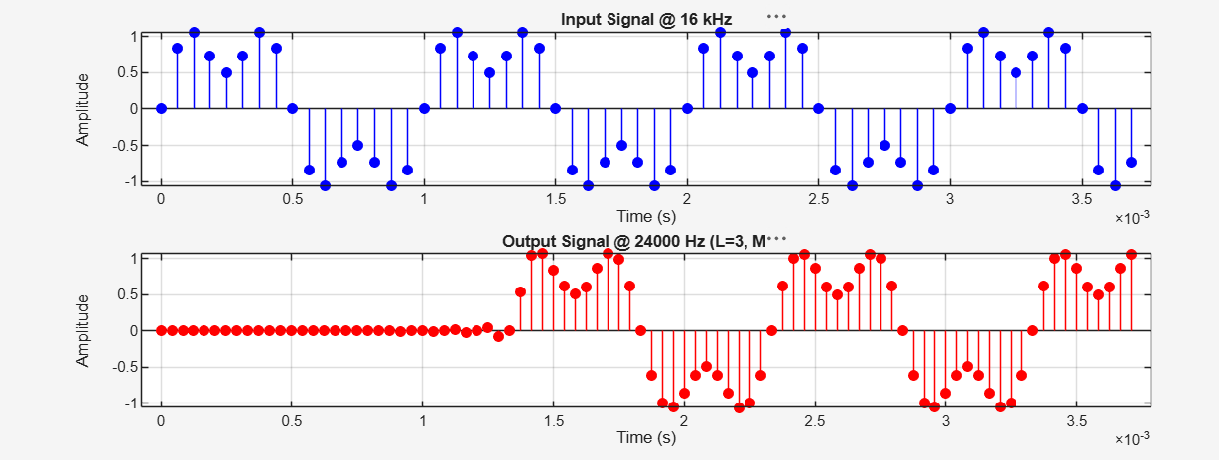
Figure 1. Input signal @ 16 kHz (top) vs. output signal @ 24000 Hz, L = 3, M = 2 (bottom).

6.2 Frequency-Domain Spectra
The spectrum of the output signal preserves both tones at 1 kHz and 3 kHz with no visible aliasing or imaging artifacts across the extended 0–12 kHz range, confirming the anti-imaging/anti-aliasing filtering was effective.
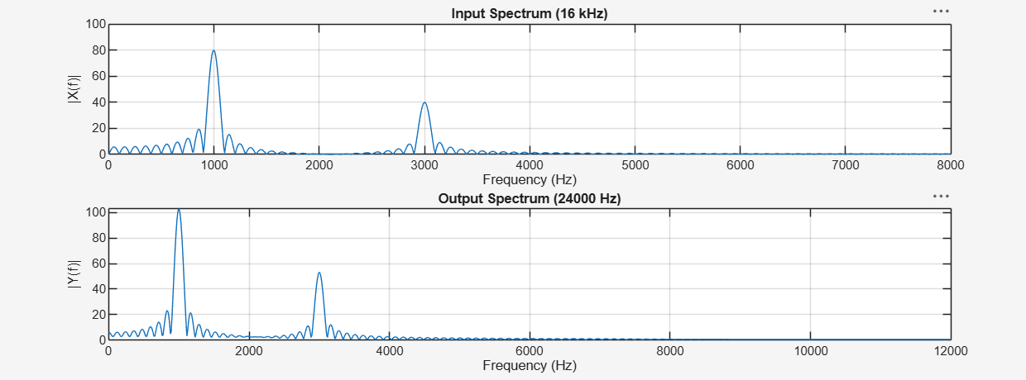
Figure 2. Input spectrum @ 16 kHz (top) vs. output spectrum @ 24000 Hz (bottom), tones preserved at 1 kHz and 3 kHz.

7. Verification Output
--- Frequency Check ---
Erroneous design (L=2, M=3): Fout = 10666.67 Hz
Corrected design (L=3, M=2): Fout = 24000.00 Hz

--- Verification ---
Input length : 160 samples at 16000 Hz (0.0100 s)
Output length: 240 samples at 24000 Hz (0.0100 s)
Achieved output sampling frequency = 24000 Hz

Built-in resample(x,3,2) length = 240 samples => Fs_out = 24000 Hz

8. Conclusion
The original design error was a swap of the interpolation and decimation factors: L = 2, M = 3 yields Fin × 2/3 = 10.67 kHz, which is the correct ratio for downsampling 24 kHz to 16 kHz, not for upsampling 16 kHz to 24 kHz. Correcting the factors to L = 3, M = 2 yields the intended output rate:
Fout = 16000 × (3/2) = 24000 Hz ✓
This was confirmed both analytically and by MATLAB simulation (explicit multirate implementation and the built-in resample function), with time- and frequency-domain plots showing clean, artifact-free conversion.

